**ToDo List App Project**

This is a basic ToDo List application. Users can register for free and start using the app. Users can create daily ToDo lists to make a note their day productive.

Project URL: <http://mytodo.sanjayinfotechy.com>

API Documentation: <http://todoapi.sanjayinfotechy.com>

Socket.IO Events Documentation: <http://todoevents.sanjayinfotechy.com>

Project Git Repository: <https://github.com/Sanjay7878/Todo-list>

**Project Flow**

Users will be first directed to the signup page. They can register for free and start using the app.

If in-case the user forgets the password, user has an option to reset the password. User will be sent a password reset link on his registered mail Id. Upon clicking user can reset the password

User can create daily ToDo list. They can set the visibility to public or private.

Users can also create a task for a particular ToDo list. They will have the option to change the status of the task to done or open, edit the task name and also delete if not required.

Users can create a subtask under a particular task in order to make their ToDo tracking easy. They will have the option to change the status of the sub-task to done or open, edit the task name and also delete if not required.

Friends Module, is much more fun for the users. Users can send friend requests to all the other users registered in the application. The user at the other end who received a friend request can either accept, decline, block or else keep the request in pending.

Upon the decision of the user at the other end. User will receive a notification in the notification option under friends dropdown tab.

Users can see sent notifications as well as received notifications. They also have an option to see received friend requests and sent requests.

If the user on the other end has accepted the request. Both the users will be able to view each other’s profile. User can see his friend's all public ToDo list and can also edit and change status.

**Screenshots of Application**

* Register Page

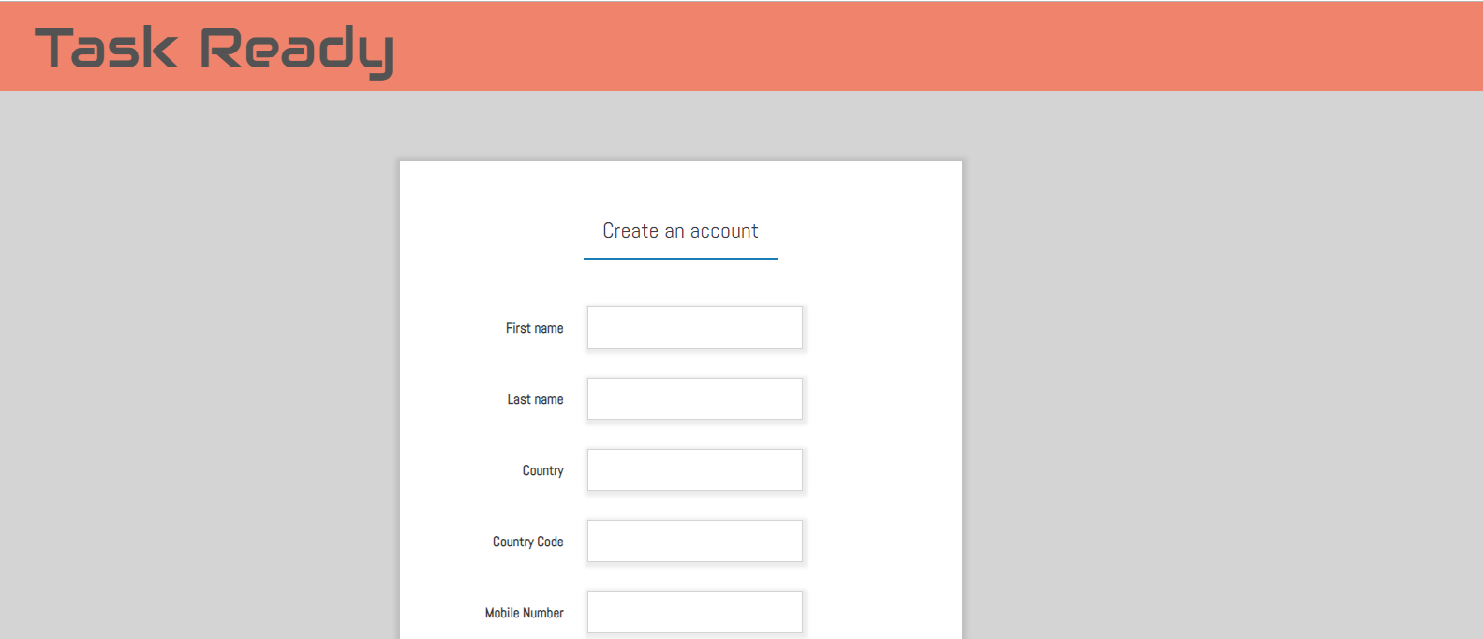



* Login Page

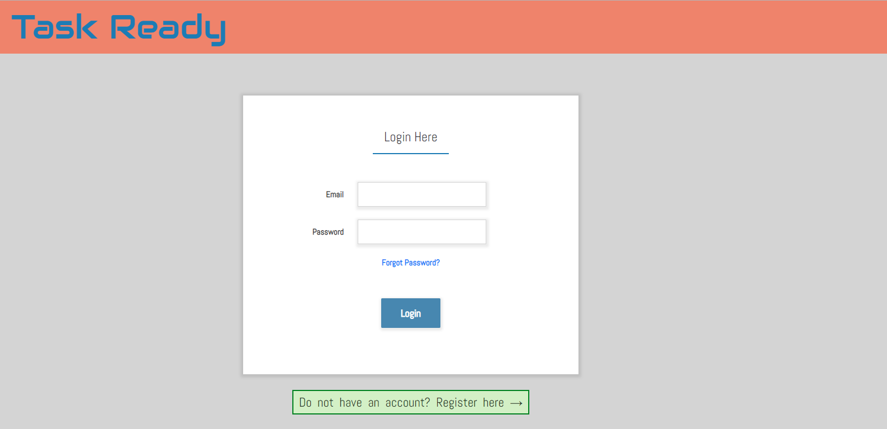

* Forgot Password Page

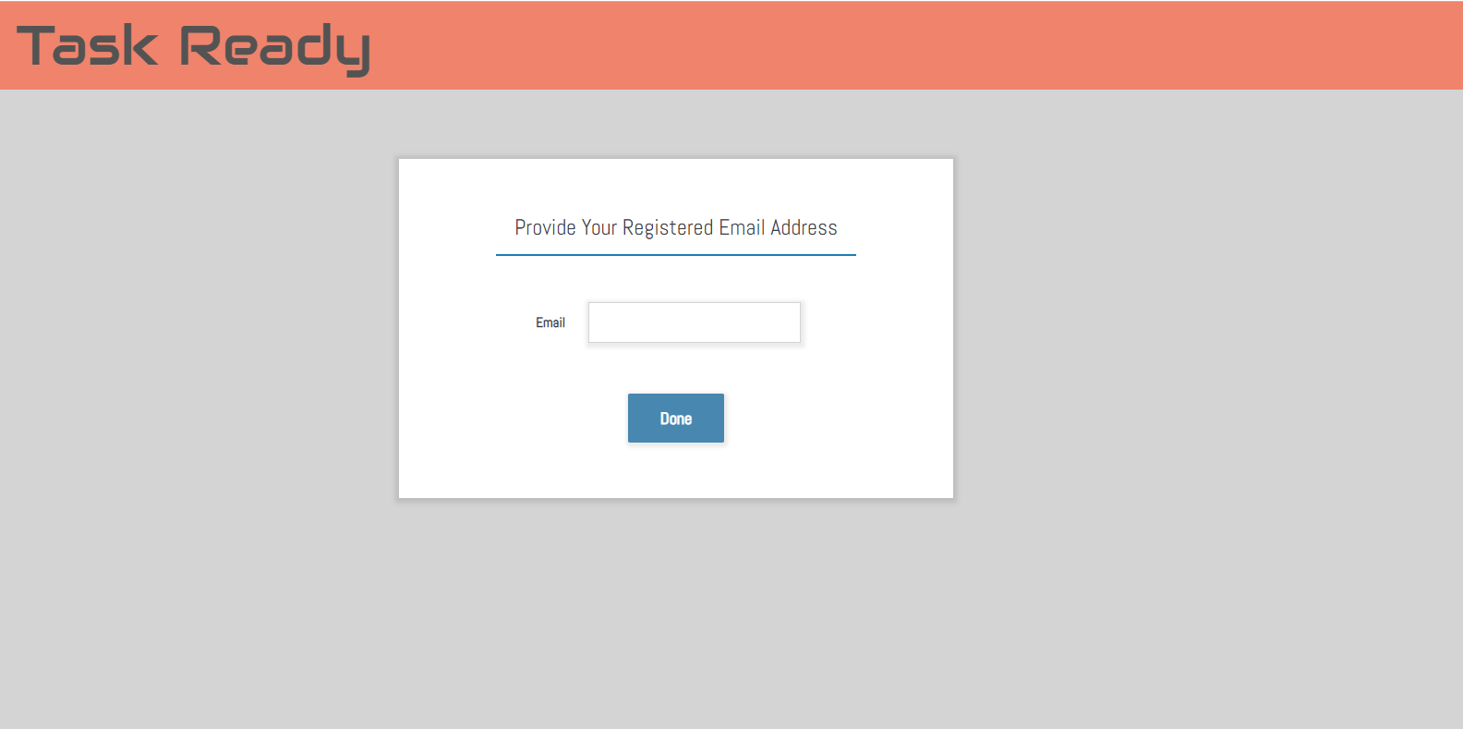

* Reset Forgot Password page

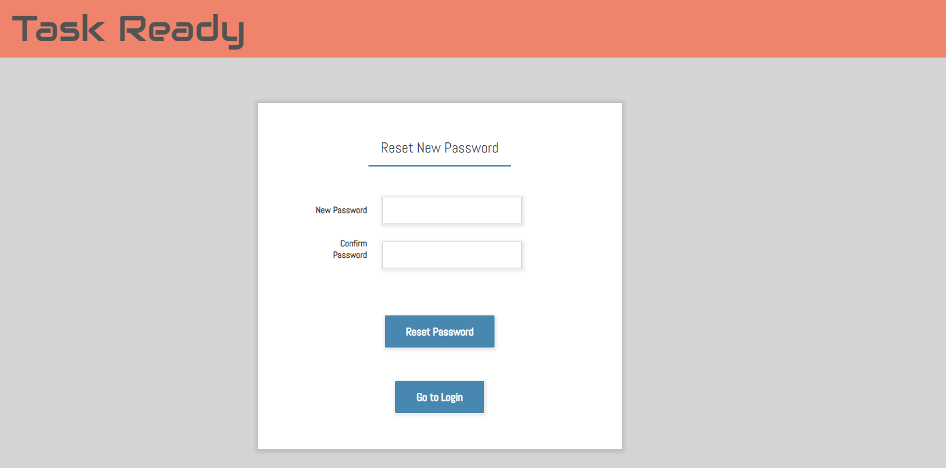

* Home Page

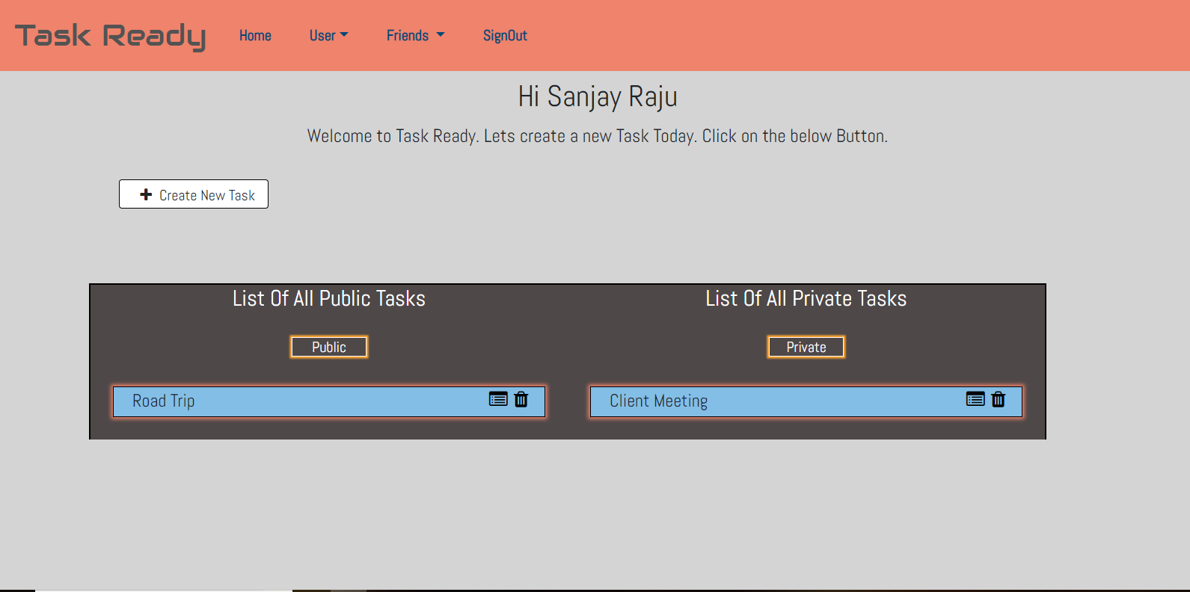

* Create New ToDo

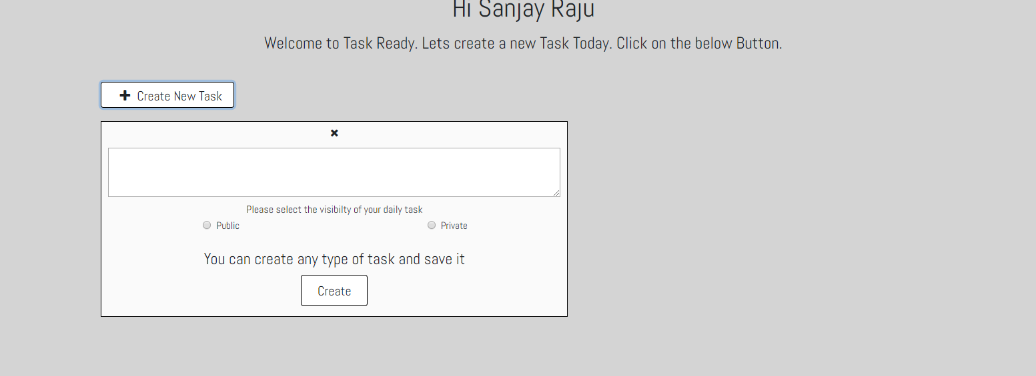

* Profile Info Page

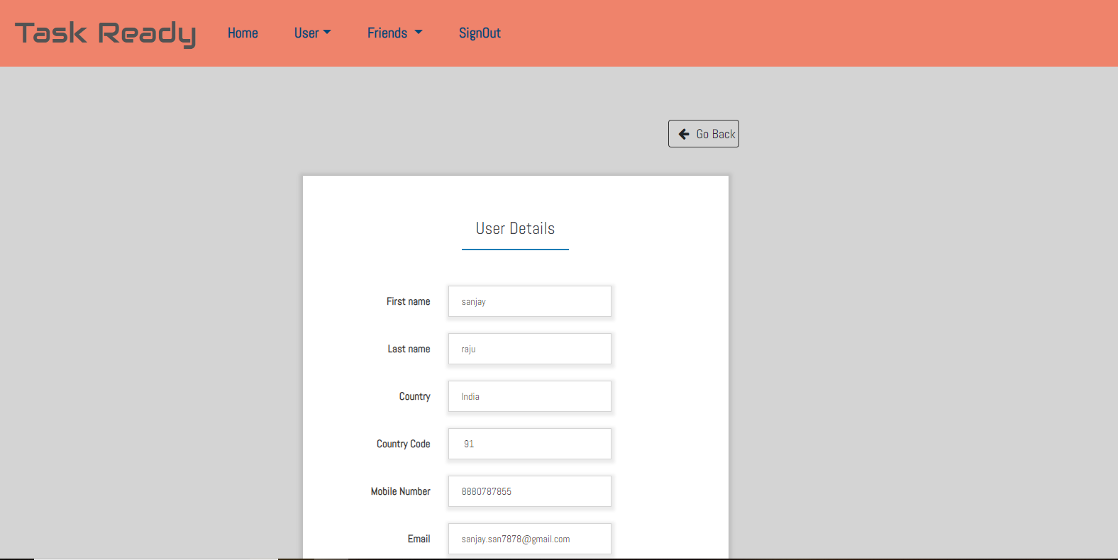

* View all Task View

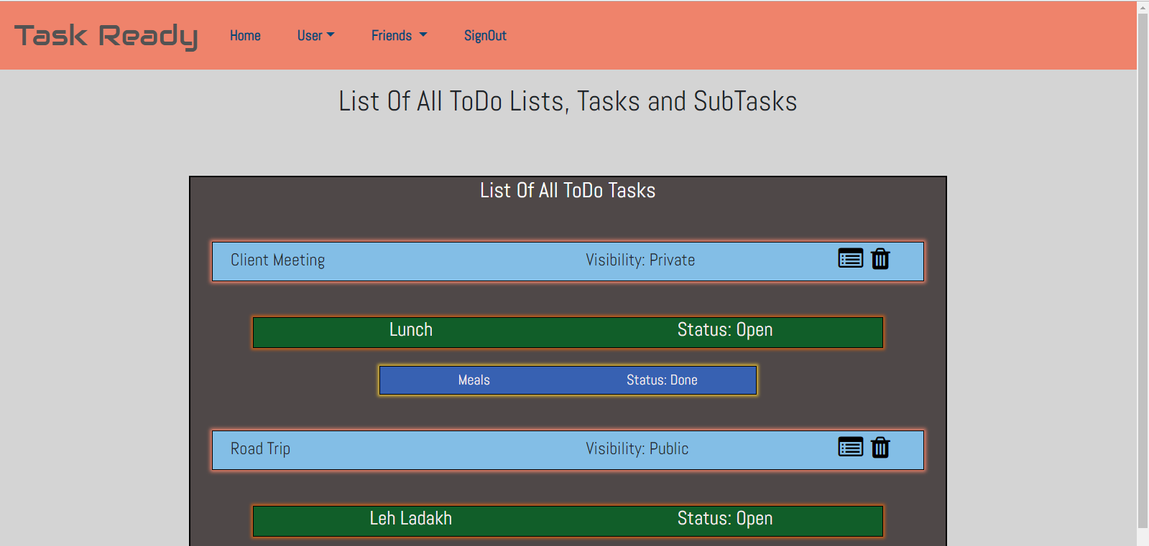

* Single ToDo List View

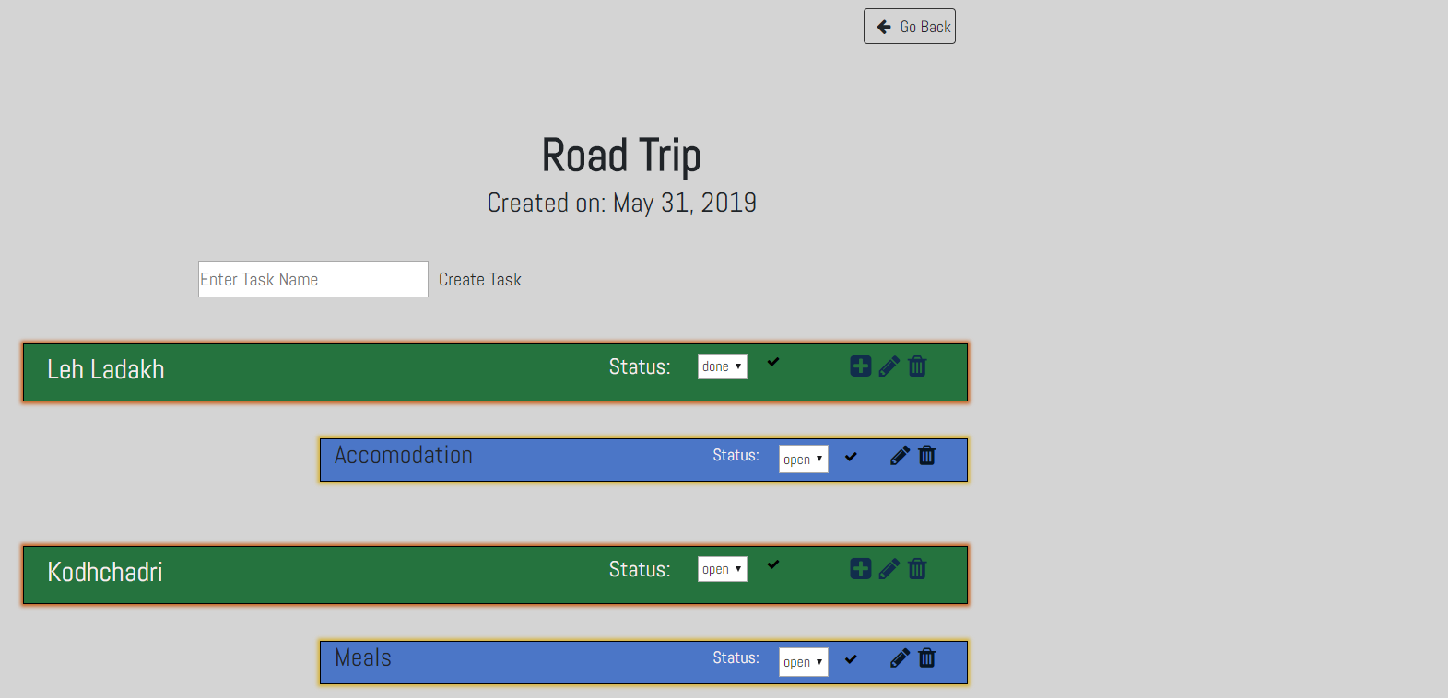

* Change Password Page

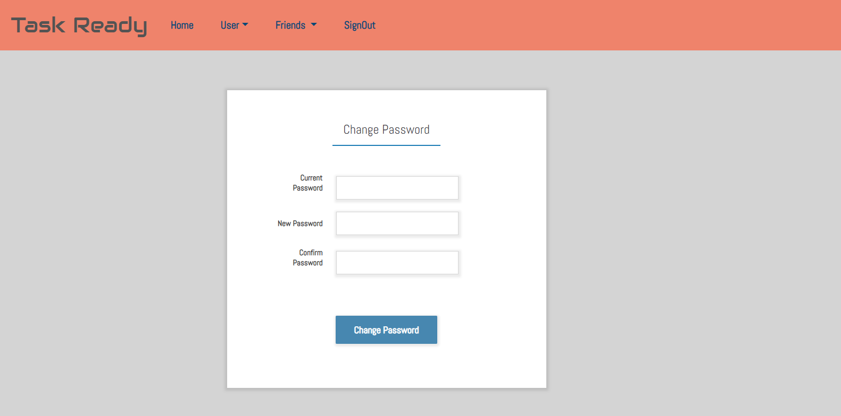

* Add Friends Page

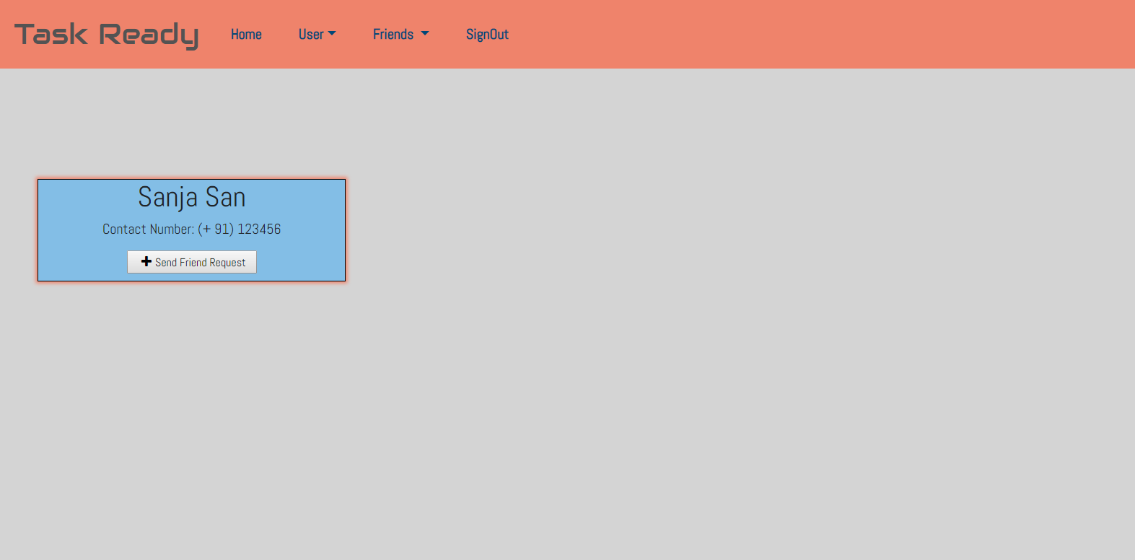

* View All Friends Page

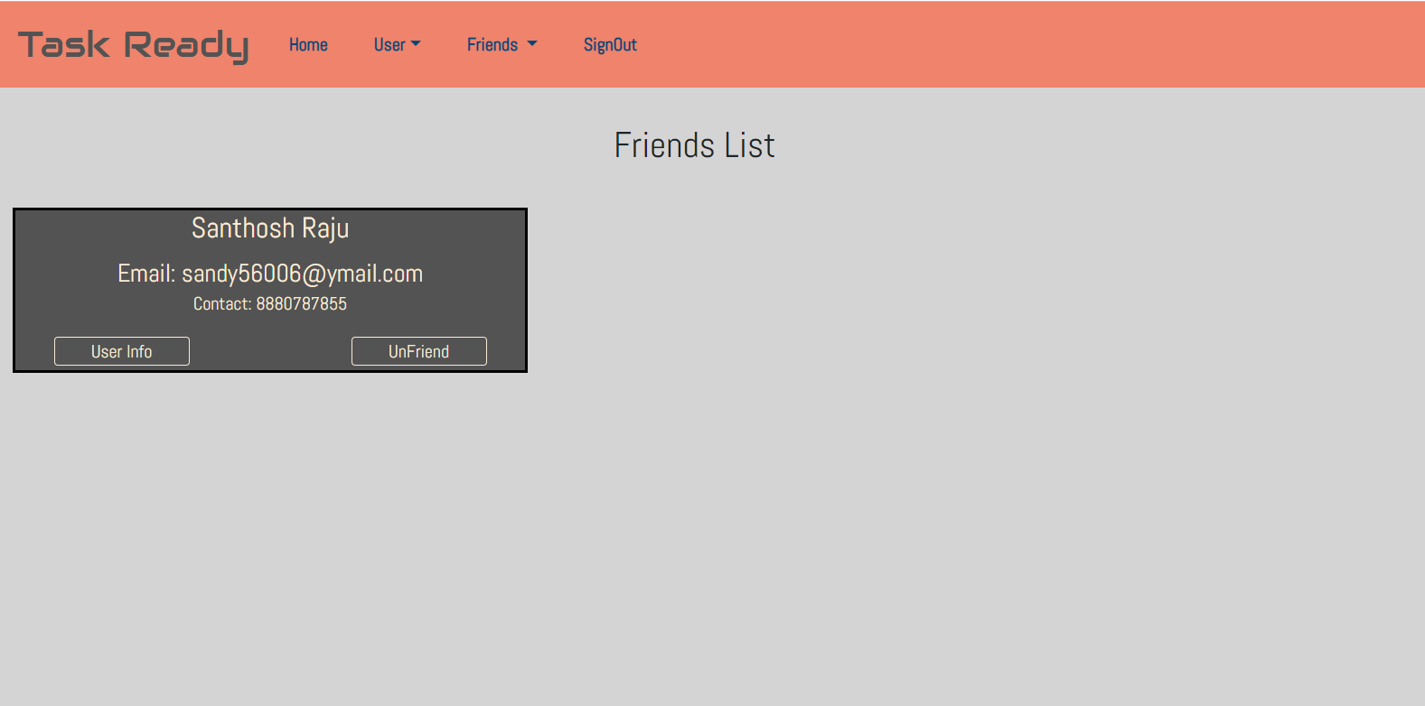

* Friends Info Page

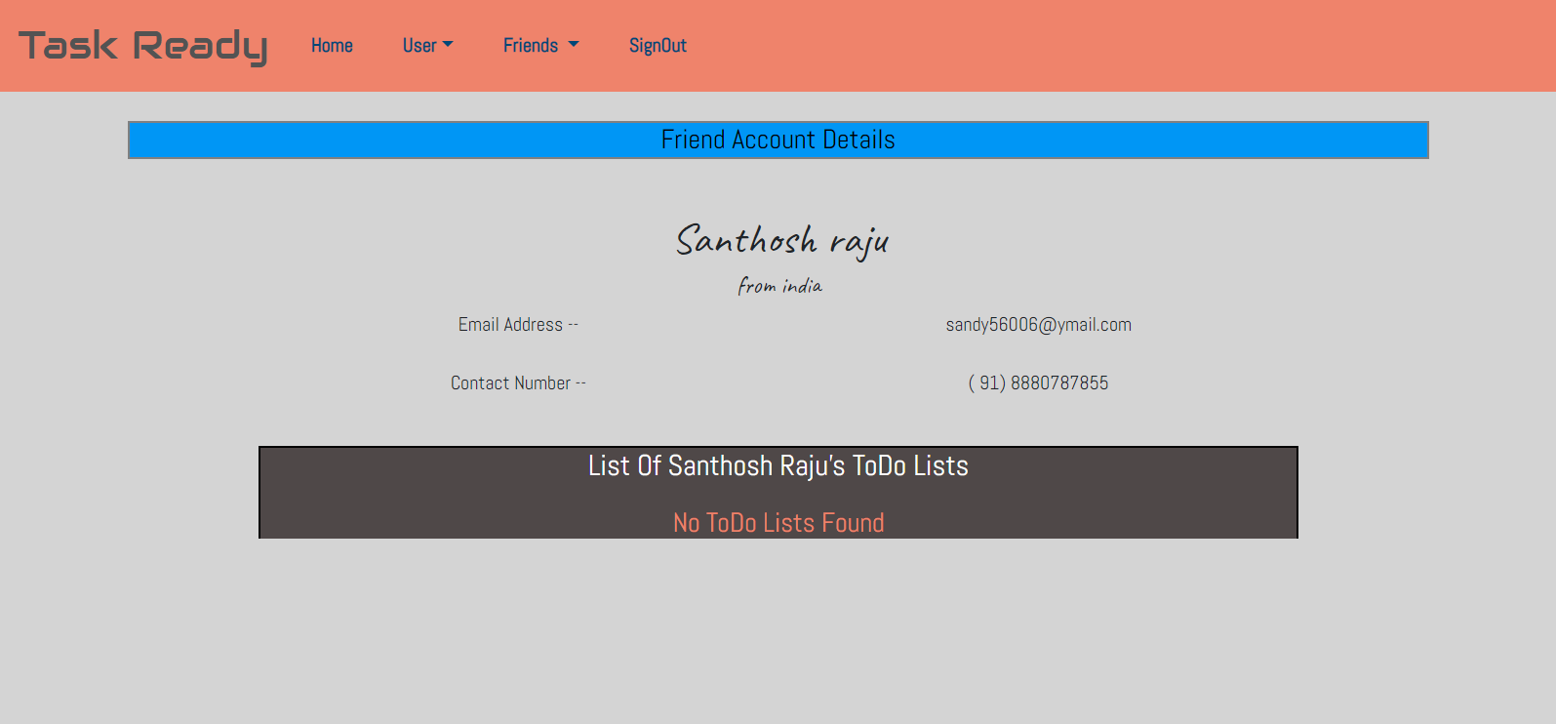

* Notifications Page

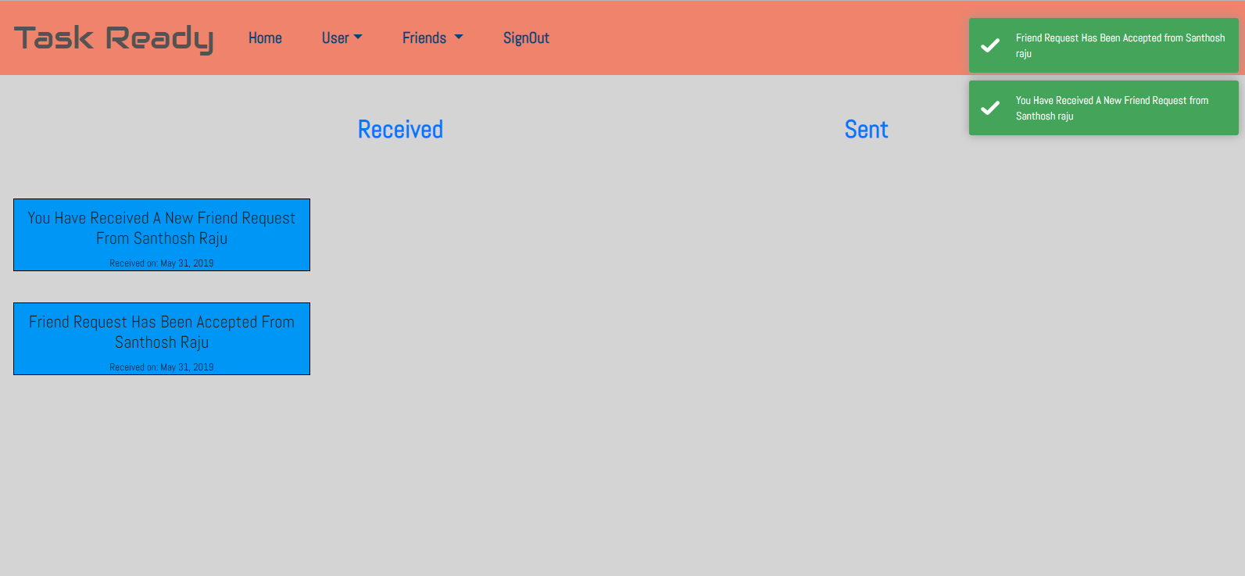

* All Requests Page

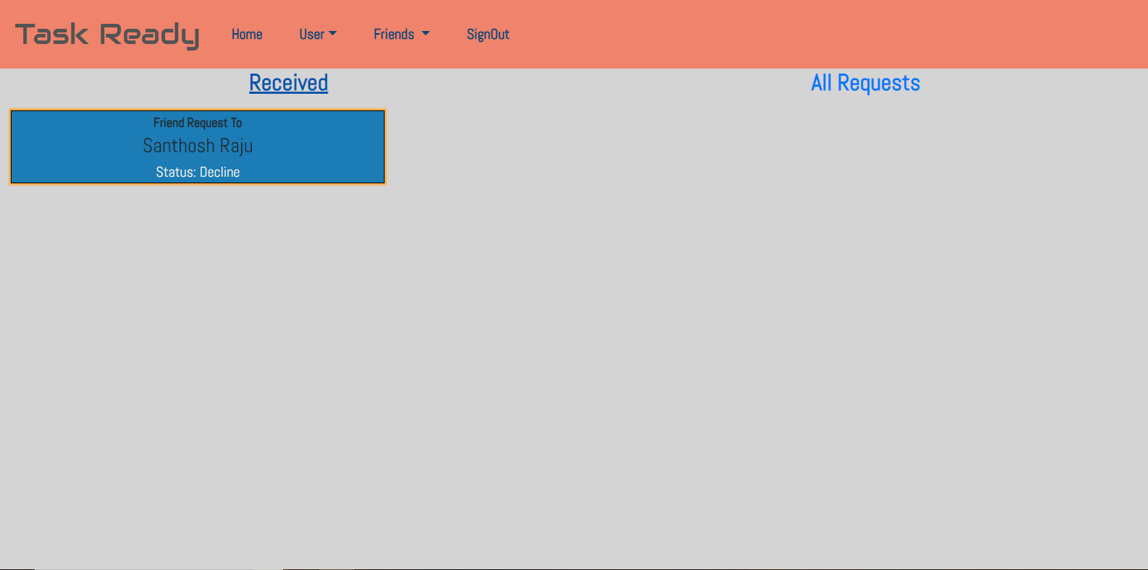

* Friend Requests Page

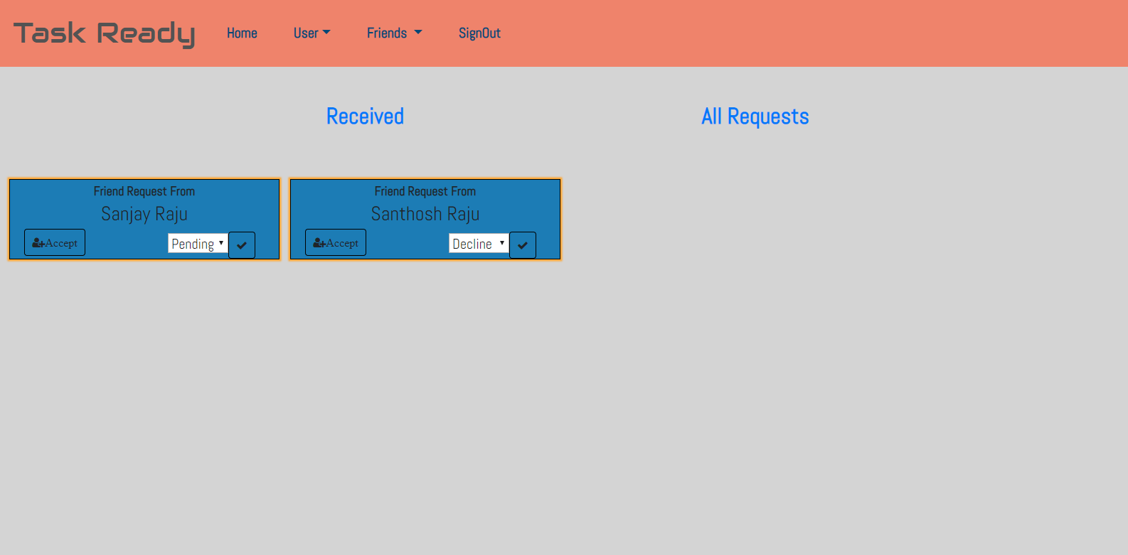

**Documentation**

All the APIs and Events are well documented using npm module apiDoc

* **APIDOC** - APIDOC of Issue Tracker App backend.
* **EventDoc** - EventDoc of Issue Tracker App backend.
* **Comments** – comments are written for every function

**Built With**

* **Angular** - The web framework used for Frontend Design
* **NPM** - Most of the modules are used
* **apiDoc** - NPM module to create the apiDoc and eventDoc

**Authors**

* Initial work – Sanjay C
* Problem Statement - Edwisor

**Acknowledgments**

Thanks for Edwisor to review this application. I would like to thank my friends, colleagues for supporting me to develop and deploy this Application.